Soundscape and human behaviour in urban open space: a systematic review and meta-analysis of a bidirectional relationship
Author information
Authors: [Author 1]¹*, [Author 2]², …
¹ [Affiliation, city, country] · ² [Affiliation, city, country]
* Corresponding author: [name], [postal address], [email]
ORCID: [0000-0000-0000-0000]
CRediT author statement Conceptualisation, [A1]; Methodology, [A1]; Software, [A1]; Formal analysis, [A1]; Investigation (screening, full-text assessment, data extraction, quality appraisal), [A1]; Data curation, [A1]; Writing — original draft, [A1]; Writing — review and editing, [A1, A2]; Visualisation, [A1]; Supervision, [A2]; Project administration, [A1].
Screening, extraction and appraisal were performed by one reviewer with AI-assisted pre-classification and human verification at every stage; no second independent reviewer was involved. This is stated in the Limitations and is the principal procedural departure from the standard two-reviewer model.
Funding: [This research received no specific grant from any funding agency in the public, commercial, or not-for-profit sectors. / Grant details.]
Declaration of competing interest: The authors declare that they have no known competing financial interests or personal relationships that could have appeared to influence the work reported in this paper.
Data availability: All review-level data are openly available. The registered protocol is at osf.io/7ew8q. The extraction table, verdict table, MMAT item-level appraisals, meta-analytic input tables, sensitivity and supplementary analyses, the protocol deviation log, and the full list of included and excluded reports with reasons are provided as Supplementary Material S1–S14. Full texts of the included articles are subject to publisher copyright and are not redistributed; each is identified by DOI.
Declaration of generative AI in the writing process: The authors used large language models to assist with record pre-classification during screening, with structured extraction from full texts, and with language editing. Every pre-classification and extraction was verified against the source by the author, who takes full responsibility for the content.
---
Abstract
Soundscape research has established how people judge acoustic environments; what they do in them has never been synthesised. We systematically reviewed and meta-analysed the relationship between the acoustic environment and observable behaviour in urban open space, treating it as bidirectional. Three databases were searched (2 August 2026) and supplemented, as registered, by citation tracking of every included study and by a fourth index; the protocol was registered before screening (osf.io/7ew8q). Ninety-eight studies were eligible. Quality was appraised with MMAT 2018 and effects pooled using random-effects REML with the Hartung–Knapp adjustment. All four clusters pointed in the predicted direction, but only two excluded zero for the mean effect: social interaction (k = 4, g = +0.68, 95% CI +0.20 to +1.16) and the perception–behaviour correlation (k = 6, r = +0.43, 95% CI +0.19 to +0.61). Prediction intervals included zero in every cluster, and with a maximum k of 6 no test of reporting bias was possible, so pooled estimates are upper bounds. The social-interaction result comes from two field experiments thirteen years apart using different noise sources; because no study contrasts natural sound against quiet, adding pleasant sound and removing unpleasant sound cannot be separated. The widely cited walking-speed effect rests entirely on low-quality studies, three of the effects manipulating audio through headphones rather than the space itself, and largely from one research programme on one route. Of the 187 directional study × behavioural-domain records, 40% run in reverse — activity generating the soundscape — with near-parity in space use, activity and social behaviour. Measurement generations accumulate rather than replace one another. Ten planning levers are derived with graded confidence; none reaches high confidence, and the best-supported action is controlling operational noise where people are meant to interact.
Keywords: soundscape; behaviour; urban open space; systematic review; meta-analysis; landscape planning
1. Introduction
1.1 The gap. Soundscape research has matured around perception. Since ISO 12913 formalised pleasantness and eventfulness as the descriptive axes, a large literature has established how people judge acoustic environments. What people do in them has been studied far less systematically, and never synthesised. Yet planning decisions are made about behaviour — whether a square is used, whether people linger, whether strangers speak to each other — not about ratings.
1.2 Why this review, why now. Seventy-one per cent of the eligible literature appeared in 2020 or later (70 of 98 studies). The field crossed a measurement threshold: GPS traces, video analytics and wearables made behaviour observable at scale for the first time. A synthesis is now possible that was not possible five years ago.
1.3 The bidirectional framing. The dominant framing treats sound as exposure and behaviour as outcome. Our corpus shows that framing is incomplete: of the 187 records that run in one direction (the unit is the study × behavioural domain, not the study), 40% run in reverse — crowd density, activity programming and companionship generate the acoustic environment. Space use, activity and social behaviour show near-parity between the two directions. A review that only asks "what does sound do to people" misses half of what has been measured.
1.4 Positioning. The nearest adjacent review (Cities & Health, 2026) covers physical activity only and is therefore a subset. Zhang et al. (2025, Landscape and Urban Planning) meta-analysed landscape → perception; this review takes the next link, perception/exposure → behaviour, and adds a methodological axis that no prior synthesis has: how behaviour itself has been measured.
1.5 Research questions.
• RQ1 — What is the magnitude and direction of the association between the acoustic environment and observable behaviour in urban open space, and does it differ by behavioural domain?
• RQ2 — How much of the evidence runs in the reverse direction (behaviour → soundscape), and in which domains?
• RQ3 — How has behavioural measurement changed, and does newer instrumentation replace or accumulate on older methods?
• RQ4 — What can landscape planning actually prescribe from this evidence, and at what confidence?

2. Methods
2.1 Registration and reporting
The review was prospectively registered on OSF Registries (osf.io/7ew8q) using the Generalized Systematic Review Registration form before screening began, and is reported following PRISMA 2020. All deviations from the registered protocol are listed in Supplementary S1 and summarised in §2.7, including those that changed a result. Analysis rules — effect-size metrics, contrast framing, handling of multiple effects within a study, and pseudoreplication — were fixed in a separate protocol document before any effect size was computed (Supplementary S2).
2.2 Eligibility criteria
Studies were eligible if they met all five criteria:
• Population — human participants (studies of animal behaviour, including soundscape ecology, were excluded).
• Setting — outdoor or semi-outdoor urban/landscape public space: parks, streets, squares, waterfronts, outdoor campus and residential open space, and recreation areas. Laboratory and virtual-reality studies were eligible when the stimulus reproduced an outdoor scene, and were included in the main synthesis with a sensitivity analysis excluding them. Indoor, in-vehicle, hospital and workplace settings were excluded.
• Exposure — the acoustic environment (noise, natural sounds, music, or soundscape as a composite) as an exposure, or the reverse pathway in which behaviour and activity shape the acoustic environment.
• Outcome — at least one observable behavioural outcome: movement (walking speed, route, crossing), staying (dwell time, sitting), space use (visitation, occupancy), social interaction, or physical activity and leisure. Self-reported behaviour was eligible. Studies reporting only perception, preference, annoyance, restorativeness or physiological response were excluded; studies whose sole behavioural outcome was stated intention were retained for sensitivity analysis only.
• Design — empirical, peer-reviewed journal article in English.

Two scope decisions were fixed at registration and are consequential for interpretation: Chinese-language literature and conference proceedings were excluded. Both are addressed in the Limitations.
2.3 Information sources and search
Three databases were searched on 2 August 2026: Web of Science Core Collection, Scopus, and PubMed. The search used three concept blocks combined with AND — acoustic environment × behaviour × urban outdoor setting — with the full strings given in Supplementary S3. The strategy was validated before execution against five benchmark papers known to be eligible; all five were retrieved.
Two supplementary identification routes were registered and both were executed. Backward and forward citation tracking was performed on every included study using the OpenAlex API. Separately, OpenAlex was searched as a fourth index to identify records absent from the three databases; 352 unique records were found and screened (Fig. 1).
2.4 Selection process
Database branch. After duplicate removal, 1,316 records were screened on title and abstract against seven numbered exclusion criteria, using AI-assisted pre-classification with human verification. Records that remained uncertain were not excluded; they were carried forward to full-text assessment, because in this literature behavioural outcomes are frequently measured but not mentioned in the abstract.
Citation-tracking branch. Backward references and forward citations of the 84 studies then included yielded 2,073 records new to the screening pool. Because citation tracking has low topical specificity, the registered three-block search logic was applied to titles as a priority filter; 1,645 records matching at most one block, or concerning animal acoustics, were deprioritised. The remaining 428 were screened on title, then 146 on abstract, then sought in full text. This automatic prioritisation was not specified at registration and is recorded as a deviation (S1, D1-3).
Supplementary-index branch. Of the 352 OpenAlex-unique records, 23 were duplicates of the pools above and 329 were screened. Two proved eligible. This branch also produced the review's clearest warning about metadata: of the five full texts obtained, two were recorded as `language=en` but were written in Korean and Japanese (English appeared only in title and abstract). Document type and language cannot be determined from index metadata alone.
Boundary rules. Three recurring boundary cases were resolved by rules fixed before individual adjudication: residential noise exposure with non-specific physical activity → excluded; behavioural intention as the sole outcome → sensitivity analysis only; reverse-direction studies with appraisal outcomes → included, since the registered definition treats the reverse pathway as eligible. A fourth rule — laboratory reproduction of outdoor scenes → sensitivity analysis only — was introduced during the citation-tracking branch and therefore applied to that branch alone; the resulting inconsistency between branches is recorded in the deviation log (S1, D6-1) and is addressed below (§3.3).
2.5 Data collection and quality appraisal
One reviewer extracted data from full texts into a fixed 16-field schema (setting, design, sample, exposure, behavioural domain, measurement method, direction, key finding, and verbatim effect statistics with their location in the source). Effect statistics were transcribed exactly as printed; no conversion or estimation occurred at extraction.
Methodological quality was appraised with the Mixed Methods Appraisal Tool (MMAT) 2018. Because the two randomised studies in the corpus reported neither the randomisation procedure nor blinding, a separate RoB 2 assessment would have added no information and was not performed; this is recorded as a deviation (S1, D2-2).
One appraisal-specific caveat deserves emphasis. Full texts were machine-extracted, and an initial extraction cap truncated 13 of the 16 citation-tracked studies. MMAT scores a criterion "can't tell" when reporting is absent, so truncation is indistinguishable from under-reporting and biases scores downward. All truncated studies were re-appraised on complete text; seven changed at least one item and four changed tier, three of them by two tiers (S12). We report this because any review using automated full-text extraction is exposed to the same artefact, and we have not seen it reported elsewhere.
2.6 Synthesis
Effects were pooled where at least three independent estimates shared a behavioural outcome and a contrast frame. Standardised mean differences were expressed as Hedges' g with the small-sample correction; 2 × 2 frequencies were converted via the odds ratio using Chinn's transformation (d = ln(OR) × √3/π); correlations were pooled on Fisher's z and back-transformed. Pooling used random-effects REML with the Hartung–Knapp adjustment, which is appropriate for the small numbers of studies available here. Heterogeneity is reported as τ², I² and Q.
Where a study contributed more than one estimate to the same cluster and contrast frame, one effect was selected by a fixed priority (most direct and objective measure > primary analysis > full sample). Where two publications shared a sample, only one entered any pool. For pseudoreplicated designs the participant n was used, not the observation n.
Because heterogeneity was substantial in two clusters, we report 95% prediction intervals (Higgins–Thompson–Spiegelhalter) alongside confidence intervals. The confidence interval describes the precision of the mean; the prediction interval describes the range in which the effect of a new study would be expected to fall, and is the quantity relevant to whether a planning decision can rely on the result.
Reporting bias could not be assessed. The registered rule restricted funnel plots and Egger's test to clusters with k ≥ 10; the largest cluster here has k = 6, so no test was performed in any cluster. Small-study effects can therefore neither be detected nor excluded, and pooled estimates should be read as upper bounds.
Subgroup analyses were registered but not performed. Splitting clusters of k = 3–6 by setting, design or measurement generation yields subgroups of one to four estimates, below the pre-specified minimum of three, and Hartung–Knapp intervals become uninterpretable at k = 2. Sources of heterogeneity were instead examined narratively.
Eight sensitivity analyses were run: leave-one-out; exclusion of MMAT-low studies; recomputation on observation n; exclusion of rank correlations; exclusion of inputs that required an assumption to reconstruct; an alternative definition of the walking-speed pool; exclusion of studies that reproduced outdoor scenes in the laboratory; and — added post hoc — exclusion of the citation-tracking branch, to test whether conclusions depended on the supplementary search route. Full results are in S8.
2.7 Departures from the registered protocol
Twenty-eight departures are recorded in full in Supplementary S1 and listed in Table A below. Ten changed a reported result; those six are stated in the text here, and the remainder concern procedure. We list all of them rather than a selection, because a deviation log that reports only the convenient departures is not a deviation log.
(1) MMAT categories were reassigned from full-text reading rather than from the extracted design string (D2-1). Category determines which items apply, so this changed tiers. The most common misassignment was treating "objective acoustic measurement plus questionnaire" as mixed methods when both components are quantitative.
(2) The pooled walking-speed cluster excludes a music-stimulus study (D3-6). Including it moves the estimate from g = −0.474 (p = .326) to −0.742 (p = .082) — that is, exclusion is the conservative choice, not one that favours our conclusion.
(3) A sign-coding error of our own was found and corrected (D3-4). The social-interaction cluster initially returned I² = 93.6%; tracing it revealed that we had coded the odds ratio of Moser (1988) in the wrong direction. After correction, I² = 43.5%. We record this because the heterogeneity statistic functioned as an error detector, which is an argument for reporting it prominently at small k.
(4) One eligible new effect was excluded from the significant cluster although including it would have strengthened the result (D5-4). CT0414 (Nanjing, MMAT high) contrasts an "auditory space" against visual and other sensory spaces — not sound against sound — and its observation records (2,249) exceed its observation units (1,167), so independence fails. Adding it would move p = .021 → .005 and I² = 49% → 77%. It is reported as a sensitivity analysis only.
(5) Truncated full-text extraction changed four quality tiers (D5-3), as described in §2.5.
(6) The result narrative was rewritten when the social-interaction cluster crossed *p* = .05 (D5-6). Our first synthesis argued that all three condition-contrast clusters included zero, and that only observational associations had accumulated. Retrieving one 1975 field experiment moved that cluster to p = .021 and the argument no longer held. We changed the claim because the result changed, not the reverse — the earlier claim is preserved verbatim in S1 so the two can be compared.
Table A. All departures from the registered protocol. Generated from the deviation log (Supplementary S1); "Yes" marks a departure that changed a reported result.
# | Section | Departure | Effect on results
D1-1 | Search and selection | All records still uncertain after title/abstract screening were carried to full text rather than excluded | No — widened retrieval, criteria unchanged
D1-2 | Search and selection | Three recurring boundary cases formalised as rules after registration, then applied uniformly | Moved 3 studies to sensitivity-only
D1-3 | Search and selection | Title-level priority filter applied to citation-tracking output (registered three-block logic) | Coverage limit; stated in Limitations
D1-4 | Search and selection | Citation-tracking branch initially stopped at 'reports sought'; completed by manual retrieval of 71 reports | Resolved — branch now complete (15 studies)
D2-1 | Quality appraisal | MMAT categories reassigned from full-text reading rather than from the extracted design string | Yes — category determines items, so tiers changed
D2-2 | Quality appraisal | RoB 2 not applied separately: only two randomised studies, neither reporting procedure or blinding | No
D2-3 | Quality appraisal | One 1978 scanned report left category-undetermined (no text layer) | No — contributes no effect
D3-1 | Meta-analysis | Five registered clusters reduced to four; space-use effects were unpoolable (no variance information) | Cluster set; studies remain in narrative synthesis
D3-2 | Meta-analysis | Analysis rules (multiple-effect priority, pseudoreplication, non-convertible inputs) fixed in a separate document before any computation | No — pre-specified
D3-3 | Meta-analysis | Three unreported values reconstructed (equal-split n; SD back-calculated from p; SE→SD) | Bounded by sensitivity ⑤
D3-4 | Meta-analysis | A sign-coding error of our own found and corrected (I² 93.6% → 43.5%) | Yes — corrected before any reporting
D3-5 | Meta-analysis | Two sensitivity axes only partially executable (observation-n available for one study; two studies report group-level n only) | Stated per axis
D3-6 | Meta-analysis | Walking-speed pool defined without the music-stimulus study | Yes — exclusion is the conservative direction (g −0.500 vs −0.742)
D4-1 | Reporting | Conceptual framework placed in Discussion rather than Results | No — presentation only
D4-2 | Reporting | English-language, journal-only restriction retained as registered | No — registered, not a deviation; consequential for interpretation
D5-1 | Citation-tracking branch | Exclusion code for language added (Chinese-language journal indexed with English metadata) | One verdict changed
D5-2 | Citation-tracking branch | Intention-outcome rule stated inconsistently across branch instructions | No — no verdict depended on it
D5-3 | Citation-tracking branch | Full-text extraction cap truncated 13 of 16 citation-tracked studies; all re-appraised on complete text | Yes — 7 items and 4 tiers changed
D5-4 | Citation-tracking branch | Four cluster-membership judgements on newly retrieved studies, including one exclusion that would have strengthened the result | Yes — see §2.7(4)
D5-5 | Citation-tracking branch | Two publication pairs share samples; one member of each pair admitted to any pool | Prevents double-counting
D5-6 | Citation-tracking branch | Result narrative revised after the social-interaction cluster crossed p = .05 | Yes — claim changed because the result changed
D6-1 | Supplementary-index branch | Laboratory-reproduction rule applied to the citation-tracking branch only | No — no such study is poolable
D6-2 | Supplementary-index branch | Registered supplementary index (OpenAlex) screened late, after self-audit found it unscreened | No — the 2 studies found contribute no effect
D6-3 | Supplementary-index branch | Index language metadata found unreliable (2 of 5 retrieved texts not in English despite language=en) | Two verdicts changed
D7-1 | Post-hoc statistical verification | τ² estimator was maximum likelihood although reported as REML; corrected and consolidated into a single module | Yes — all four clusters recomputed
D7-2 | Post-hoc statistical verification | Walking-speed pool violated our own one-effect-per-study rule; the two experiments of one study combined as pre-specified | Yes — k 4 → 3, p .179 → .326
D7-3 | Post-hoc statistical verification | Two correlational inputs did not match the source: one effect had been constructed at pooling although extraction recorded none; one used a sample size that was not the analytic unit | Yes — k 7 → 6, r .409 → .425
D7-4 | Post-hoc statistical verification | The rank-correlation sensitivity excluded nothing because the source field was overwritten before filtering | Yes — real result k = 4, r = .484

3. Results
3.1 Study selection
Database searching returned 2,073 records (Web of Science 1,010; Scopus 850; PubMed 213). After removing 757 duplicates, 1,316 records were screened, 1,127 were excluded, and 189 reports were sought. Eighty-nine could not be obtained — 84 of which had been classified as uncertain at screening — leaving 100 full texts assessed. Sixteen were excluded and three reserved for sensitivity analysis, yielding 81 studies from this route.
Citation tracking of those studies produced 2,073 records new to the pool (413 backward, 1,660 forward). After priority filtering, 428 were screened on title, 146 on abstract, and 79 sought in full text; 54 were obtained and assessed, of which 38 were excluded and one reserved for sensitivity analysis. This route contributed a further 15 studies — 19% of the database yield.
The supplementary index contributed 329 screened records, 15 sought, five assessed and two included (Fig. 1). Neither contributes a poolable effect. The exclusion profile of this branch is itself informative: 147 of 314 exclusions (47%) were non-empirical — book reviews, editorials, commentaries and obituaries — because OpenAlex indexes far more broadly than the three databases. Absence from WoS/Scopus/PubMed is therefore weak evidence of a missed study.
The final corpus is 98 studies, with four additional studies reserved for sensitivity analysis (102 analysed in total). Study characteristics are given in Table 1 and listed in full in S5.
Table 1. Characteristics of the 98 included studies. Percentages are of 98 studies; categories marked † allow a study to appear more than once. The full study-level listing (identifier, route, year, journal, title, country, setting, design, sample, exposure, behavioural domain, measurement generation, direction, quality) is Supplementary S11.
Characteristic | Studies | %
Publication period
≤2009 | 5 | 5%
2010–2019 | 23 | 23%
2020–2026 | 70 | 71%
Study design
Mixed observation + survey | 34 | 35%
Survey | 25 | 26%
Field or natural experiment | 19 | 19%
Field observation | 7 | 7%
Sensor / big data | 6 | 6%
Laboratory / VR experiment | 5 | 5%
Other / not reported | 2 | 2%
Setting †
Street | 41 | 42%
Park | 32 | 33%
Square / plaza | 10 | 10%
Other | 8 | 8%
Campus | 5 | 5%
Residential open space | 4 | 4%
Waterfront | 4 | 4%
Country †
China | 38 | 39%
Spain | 7 | 7%
United Kingdom | 6 | 6%
Germany | 5 | 5%
Italy | 4 | 4%
Australia | 4 | 4%
Czechia | 4 | 4%
France | 3 | 3%
Other countries (n = 25) | 42 | —
Direction of relationship
forward | 57 | 58%
reverse | 33 | 34%
both | 8 | 8%
Behavioural measurement generation †
G1 | 54 | 55%
G2 | 42 | 43%
G3 | 24 | 24%
Methodological quality (MMAT 2018)
High | 22 | 22%
Moderate | 40 | 41%
Low | 36 | 37%

G1 = self-report; G2 = systematic observation; G3 = sensing, GPS, video or big-data measurement of behaviour.
The two large branches differed instructively in yield. Records for which an abstract could be retrieved mechanically and confirmed a behavioural outcome converted at 46% (17 of 37); records for which no abstract was machine-retrievable, and which therefore passed on title alone, converted at 0% (0 of 17). Abstract availability, not topical plausibility, governed screening accuracy — which also implies that the 22 unretrieved title-only records are unlikely to have changed the corpus.
3.2 Study characteristics
The corpus is young and unevenly distributed. Seventy of 98 studies (71%) appeared in 2020 or later; the median publication year is 2022, and the range extends back to 1975. Where a participant count is reported (56 studies) the median is 124 (IQR 30–400); the remaining studies report non-participant units — street segments, GPS trajectories, street-view sample points — the largest being 81,403 cycling trips.
Settings are dominated by streets (41) and parks (32), with squares (10), campuses, residential open space and waterfronts contributing the remainder. Geographically the evidence is concentrated: 38 of 98 studies (39%) were conducted in China, followed by Spain (7), the United Kingdom (6) and Germany (5) (Fig. 7a). Given that soundscape appraisal is culturally contingent, this is the single most important constraint on generalisation. Figure 7b shows a second, less obvious asymmetry: reverse-direction studies appear only from the mid-2010s, so the bidirectional evidence base is younger still than the corpus as a whole.
Most consequentially for what can be concluded, only 19 studies (19%) manipulated the acoustic environment in the field. The modal design is a mixed observational-and-survey study (34), followed by survey (25). The literature observes the acoustic environment far more often than it changes it.
3.3 Methodological quality
Of the 98 included studies, 22 were rated high, 40 moderate and 36 low on MMAT (Fig. 8). Two findings in the item-level pattern matter more than the tier distribution.
First, the two randomised studies are given no credit for their design. Neither reports how randomisation was performed, whether groups were comparable at baseline, or whether assessors were blinded; all three items are scored "can't tell", leaving them with one and two criteria met respectively. The strongest design in the corpus yields among its weakest appraisals, purely through under-reporting. They are not, however, the corpus's weakest studies in absolute terms: four studies met no criterion at all.
Second, and generalising that observation, the largest deficits are deficits of reporting rather than of conduct. Sample representativeness was clearly met in 10 of 51 quantitative descriptive studies (20%) and low non-response bias in 16 of 51 (31%); confounding was adequately controlled in 9 of 22 non-randomised studies (41%). In a field that reports sound pressure to three decimal places, response rates are routinely absent.
Excluding the five studies that reproduced outdoor scenes in virtual reality changes no pooled estimate, because none of them contributed a poolable effect; they enter the narrative synthesis only. This also resolves the branch inconsistency noted in §2.4 (D6-1): the rule was applied to only one branch, but since no such study is poolable, the inconsistency has no quantitative consequence.
3.4 Meta-analyses
Four clusters met the pooling threshold (Fig. 2).
Table 2. Pooled estimates for the four behavioural clusters. Random-effects REML with the Hartung–Knapp adjustment. CI = confidence interval (precision of the mean); PI = 95% prediction interval (range expected for a new study). Every prediction interval includes zero.
Cluster | k | Metric | Estimate | 95% CI | 95% PI | p | I²
Walking speed (natural sound vs noise) | 3 | g | −0.474 | −2.055, +1.108 | −9.13, +8.19 | .326 | 81.4%
Staying / dwell time (positive sound vs control) | 3 | g | +0.343 | −0.091, +0.778 | −1.67, +2.36 | .077 | 54.4%
Social interaction (natural/quiet vs noise) | 4 | *g* | +0.679 | +0.201, +1.158 | −0.42, +1.78 | .020 | 48.6%
Soundscape perception ↔ behaviour | 6 | r | +0.425 | +0.191, +0.613 | −0.24, +0.82 | .007 | 92.0%

PI = prediction interval.
All four estimates point in the theoretically predicted direction: noise accelerates passage, positive sound extends stay, quiet and natural sound increase social interaction, and appraisal covaries with behaviour at moderate strength. The clusters differ sharply, however, in whether that direction is established with any precision.
Social interaction reaches significance on the strength of two field experiments thirteen years apart — Mathews and Canon (1975), in which a lawnmower raised the ambient level from ~50 to ~87 dB(C) and helping behaviour fell from 20 of 40 to 5 of 40 (OR = 7.00, d = +1.07), and Moser (1988), which used roadworks noise in a Paris street, applied the same 2 × 2 logic, and reached the same sign. The two used unrelated noise sources and different helping paradigms, which makes the agreement more informative than k = 4 alone suggests. (Mathews and Canon do not state where data were collected, so we do not claim cross-national replication.)
This significance is nevertheless contingent on one study obtained by citation searching. The full leave-one-out profile for this cluster is: removing Chen and Kang (2023) gives g = +0.581 (p = .056); removing Chen et al. (2024), +0.775 (p = .070); removing Moser (1988), +0.803 (p = .043); removing Mathews and Canon (1975), +0.596 (p = .057). Three of four removals cross back over *p* = .05. The cluster is significant as a set rather than on the strength of any single study, and the citation-searched study is the one whose removal returns the cluster to its pre-retrieval state. We report this as a limitation of the result and, simultaneously, as evidence that the registered supplementary search route was not a formality.
The correlational cluster, by contrast, is insensitive to search route (r = .425 with citation tracking, .445 without) and to any single study (leave-one-out range r = .372 to .484) but carries very high heterogeneity (I² = 92.0%), which is expected given that it mixes forward and reverse pathways and several behavioural outcomes.
Prediction intervals qualify both significant results. The two intervals that exclude zero do so for the mean effect; the interval within which a new study's effect would be expected to fall includes zero in every cluster, including social interaction (−0.42 to +1.78) and the correlational cluster (r = −0.24 to +0.82). Neither result licenses the expectation that a further study will reproduce the sign. Reporting bias compounds this: with a maximum k of 6, no funnel plot or Egger test was possible, so small-study effects can be neither detected nor excluded, and every pooled estimate should be read as an upper bound.
The walking-speed cluster is the weakest in the corpus, and its weakness is instructive. All three contributing effects come from studies rated low on MMAT; excluding low-quality studies leaves nothing to pool (k = 0). Three high-quality walking studies exist in the corpus, but none could enter the pool — one manipulated music tempo rather than environmental sound (Franěk et al., 2014), one reported no direct test of noise against speed (Franěk & Režný, 2021), and one analysed augmented footstep audio delivered through headphones (Schrapel et al., 2022). The most frequently cited claim in this literature — that noise makes people walk faster — rests on the least secure evidence in it.
3.5 Direction of the relationship (RQ2)
Across the 212 domain-level records extracted from the 98 studies, 113 ran forward (sound → behaviour), 74 ran in reverse (behaviour → sound) and 25 were bidirectional. Reverse-direction records are 40% of the directional records (74 of 187 forward-or-reverse; 35% if the bidirectional records are placed in the denominator) (Fig. 4). The unit here is the study × behavioural-domain record, not the study.
The reverse pathway is not spread evenly. Movement (33 forward vs 8 reverse) and staying (16 vs 8) are dominated by forward designs — the behaviours that are easiest to manipulate experimentally. Space use (26 vs 23), activity (18 vs 21) and social behaviour (20 vs 14) approach parity. Where behaviour is collective and sustained, researchers have measured how it produces the acoustic environment: crowd density predicting sound pressure, activity programming generating broadcast music, companionship altering what is noticed. A unidirectional framing would discard nearly half of what this literature has measured.
3.6 Measurement generations (RQ3)
Sensor, GPS, video and big-data measurement of behaviour grew from four studies in 2010–2019 to 20 in 2020 onward. Over the same period self-report grew from 14 to 39 and systematic observation from 11 to 28 (Fig. 5). Newer instrumentation has not displaced older methods; it has been layered on top of them. Twenty-two studies use two or more generations concurrently. The answer to RQ3 is accumulation, not succession — which matters because it means the field's capacity for triangulation is growing faster than its raw output.
3.7 Coverage and gaps
Every behavioural domain × sound source cell in the evidence map is populated (Fig. 3), with one exception: aircraft noise appears in four domain-level records, from two studies. Research around airports has remained framed by health and annoyance, and has almost never measured what people do with outdoor space.
4. Discussion
4.1 A bidirectional framework for soundscape and behaviour
Figure 6 sets out the framework this review arrives at. Two arcs close a loop. The forward arc runs acoustic environment → appraisal → behaviour and is the one the field has assumed. The reverse arc runs activity and occupancy → sound production → acoustic environment, and accounts for 40% of the directional records. Between them sit moderators that determine whether a given sound produces approach or avoidance: setting type, visual–acoustic congruence, purpose of stay, and cultural context.
Behaviour is not a single outcome but a gradient of engagement — avoid, pass, linger, interact, appropriate — and the evidence attaches to that gradient unevenly. Placing the pooled estimates on the gradient (Fig. 6) makes the field's shape visible in one view: the two ends are weakly evidenced, and the strongest quantitative signal sits at interact.
The framework's value is diagnostic as much as descriptive. It shows that the literature has organised itself around the forward arc while producing nearly half its measurements on the reverse one, and that the behavioural gradient has been sampled without regard to which rungs planning actually acts on.
4.2 What the evidence supports, and how strongly (RQ4)
We translated the corpus into ten planning levers — things a designer or operator can change — each carrying a confidence grade derived from study count, MMAT quality composition, whether the interval excludes zero, setting diversity, and behaviour under sensitivity analysis (Table 3).
No lever reaches high confidence. Four are moderate (audio programming; natural sound introduction; quiet route provision; control of mechanical and maintenance noise), five are low, and one is very low. That distribution is itself the review's principal finding for practice: this field can currently support hypotheses to test with monitoring, not design standards.
Table 3. Ten planning levers derived from the corpus, with confidence grading. Confidence combines the number of contributing studies, their MMAT composition, whether a pooled interval excludes zero, diversity of settings, and behaviour under sensitivity analysis. No lever reaches high confidence. Mixed under Direction means that studies disagree in sign, not that the lever has several effects. Full evidence, caveats and study lists are Supplementary S14.
Lever | What is changed | Behavioural outcome | Direction | Studies | MMAT mix | Confidence
L1 Programmed music in public space | Sound draws attention, pulls people towards the source and slows them, extending stay | Staying (dwell time); space use (approach to source); movement (slower wandering) | promotes | 7 | high 3 · mod 2 · low 2 | moderate
L2 Natural sound provision (water and birdsong) | Natural sound raises perceived restoration and safety, encouraging talk and lingering | Social interaction; staying (dwell time); vitality of activity | promotes | 6 | high 2 · mod 3 · low 1 | moderate
L3 Quiet routes for walking and cycling | Noise avoidance shifts route and mode choice, moving trips onto quieter alignments | Movement (route choice, mode choice, cycling volume) | promotes | 8 | high 4 · mod 1 · low 3 | moderate
L4 Remove or reschedule mechanical plant noise | Unpleasant machinery noise creates avoidance routes and acceleration, cutting stay and talk | Social interaction; staying; space use (removal of avoidance routes) | promotes | 7 | high 2 · mod 3 · low 2 | moderate
L5 Quiet side and designated quiet zones | A quiet façade or designated zone lowers the psychological barrier to outdoor stay and walking | Activity (walking, exercise, rest); space use; staying | mixed | 10 | high 2 · mod 4 · low 4 | low
L6 Acoustic zoning and enclosure of functions | Separating and enclosing noise-generating functions changes the density and interaction of adjacent activity | Space use (crowd density); social interaction (frequency, duration); staying | mixed | 6 | high 1 · mod 5 | low
L7 Programming sound-generating public activities | Human sound and activity attract watching and joining, converting passage into stay | Staying (watching, lingering); social interaction; space use | promotes | 6 | high 1 · mod 2 · low 3 | low
L8 Auditory guidance and warning signals | Directional signal sound directly adjusts crossing trajectory and response timing | Movement (crossing accuracy, detection timing, smoothness of deceleration) | mixed | 4 | high 1 · mod 2 · low 1 | low
L9 Slowing pedestrian pace by natural sound | Noise provokes avoidance and speeds passage; natural sound is assumed to reverse it | Movement (walking speed) | mixed | 5 | high 1 · low 4 | very low
L10 Speech-interference criteria for siting social space | Noise interferes with speech, forcing conversation to stop or voices to rise, and eventually deterring verbal interaction altogether | Social interaction (conversation duration, vocal effort); acceptance of verbal interaction | promotes | 3 | high 2 · mod 1 | low

How to read the grades. moderate (4) — Include in a design proposal, with post-occupancy monitoring · low (5) — Test as a hypothesis; do not write into a standard or guideline · very low (1) — No prescriptive basis at present.
Two attributions matter more than the grades.
First, the social-interaction result cannot be attributed to either adding natural sound or removing noise. It would be convenient to read the significant cluster as evidence for water features and birdsong, and equally convenient to read it as evidence for silencing machinery. Neither reading is supported. Splitting the four effects by exposure gives almost identical means (natural sound +0.76, machinery noise +0.75), and removing the roadworks study raises rather than lowers the pooled estimate (+0.65 → +0.77). More fundamentally, the two natural-sound studies contrast birdsong and water against traffic and construction — they add natural sound and remove noise simultaneously. The corpus contains no contrast of natural sound against quiet, so the two mechanisms are not separately identified by any study in it. What can be said is narrower: the increment that carried this cluster across the significance threshold came from one machinery-noise experiment retrieved by citation searching.
Second, the walking-speed literature is narrower than its citation count suggests. Beyond the quality collapse already reported, two structural features emerged during appraisal. Most of the pooled effects manipulated audio through headphones during a walk rather than changing the sound of the space. And the walking evidence is substantially one research programme: two of the three pooled effects come from studies by the same Czech group (Franěk et al., 2018, 2019), and the two new high-quality walking papers are from the same group on the same 1.75–1.8 km circuit, two of them sharing an identical belt-camera and annotation protocol. The remaining pooled effect is an Algerian field observation whose sign is opposite (Berkouk et al., 2020).
Outside the pool, one study did change the sound of a real street: Ba et al. (2024) ran covert observation under traffic noise at 55.6 versus 70.5 dB(A), crossed with plant odour. Mean crowd speed was about 1.14 m/s under the low level and about 1.21 m/s under the high level — roughly 0.07 m/s faster under noise, in the direction the literature predicts, and the authors note the largest difference between any two measurement grids was 0.06 m/s. It is rated low on MMAT. So the one real-environment manipulation available produces an effect of a few centimetres per second. A claim repeated on one route in one city, largely through headphones, is not a replicated finding, and the meta-analytic k does not reveal this.
4.3 Implications for landscape planning
The practical reading of Table 3 is ordered by what can be defended.
Act on operational noise first. The best-supported behavioural consequence in this corpus is that machinery noise suppresses social behaviour — including help offered to strangers. Ventilation plant, mowing schedules and construction windows are within routine operational control, cost little to change, and are supported by two independent field experiments using different noise sources.
Treat added sound as a dwell-time instrument, not an attraction device. Music extends the stay of people already present; the one high-quality test of arrival (Aletta et al., 2016) found no effect on the number of people stopping. Programming justified by projected visitor counts overstates what the evidence shows.
Introduce a speech-intelligibility criterion for social space siting (lever L10, new in this revision). Where people are meant to talk — bench clusters, terraces, meeting points — the relevant threshold is not annoyance but whether conversation survives. The evidence supports a continuous gradient rather than a cut-off: roughly a quarter-point increase in self-reported voice-raising per decibel (Montes González et al., 2023). That is enough to compare candidate locations, not enough to set a standard.
Do not use walking speed as a design KPI, and do not transfer headphone findings to public space.
The full set of prescriptions we consider unsupported is given in Table 3 notes; two are worth flagging because they are common in practice. Masking traffic noise with water to increase use has no behavioural test in this corpus at all — the belief is imported from perception studies. And noise reduction as a route to physical activity is contradicted rather than merely unsupported: two of the largest datasets here find noise positively associated with activity (Dzhambov et al., 2026; Huang et al., 2023), because activity concentrates where cities are loud.
4.4 Methodological implications
The field measures sound far better than it measures people. The largest quality deficits are not design flaws but reporting omissions — sample representativeness clearly met in one study in five, low non-response bias in roughly one in three. A literature that reports sound pressure to three decimals routinely omits its response rate. The two randomised studies score lowest for exactly this reason.
Measurement generations accumulate rather than replace. Sensing has grown fastest, but self-report and systematic observation grew with it, and twenty-two studies now combine two or more. The field's capacity for triangulation is growing faster than its output — an opportunity, if studies report enough for the layers to be compared.
A caution for evidence synthesis itself. Automated full-text extraction interacts badly with appraisal instruments that score unreported items as "can't tell". Truncated extraction moved four of sixteen studies down at least one quality tier, three of them by two tiers, and made a whole search route look like it had retrieved weaker work. The bias is one-directional and invisible without a deliberate audit. We recommend that reviews using machine extraction report their extraction limits and verify that appraised studies were assessed on complete text.
A second caution concerns index metadata. Two of five full texts retrieved through the supplementary index were indexed as English but written in Korean and Japanese. Reviews that enforce a language criterion from metadata rather than from the document will silently violate their own protocol.
4.5 Research agenda
• One well-reported walking experiment would change a whole cell. Manipulate the sound of a real space (not headphones), randomise, report the procedure, baseline comparability and blinding. The current pooled estimate rests on studies that would each fail two MMAT criteria.
• Aircraft noise and behaviour is effectively empty — two studies. Research around airports has stayed inside health and annoyance framings and has almost never asked what people do with outdoor space.
• Close the design → acoustic output → behaviour chain. Natural-sound evidence is almost entirely loudspeaker playback. No study verifies that planting produces birdsong that then changes behaviour.
• Measure persistence. Almost all interventions run for hours or days; the longest is one season. Whether behavioural change survives withdrawal, or habituates, is unknown — and it is what budget decisions turn on.
• Build reverse-direction prediction rules. Space use, activity and social behaviour show near-parity between directions, yet only a handful of studies give rules for predicting the sound a design will generate from the activity it hosts.
• Report the basics. A substantial share of otherwise eligible studies could not enter any pool because group n, SD, or the analytic unit was not stated.

4.6 Limitations
The corpus is geographically narrow (39% of studies from China) and young (71% since 2020), so pooled estimates should not be read as culturally general. English-language and journal-only restrictions, fixed at registration, exclude a literature in which Chinese-language contributions are substantial. One hundred and twenty-two reports could not be retrieved across the three routes (89 database, 25 citation-tracking, 8 supplementary index); retrieval was 92% for citation-tracked records whose abstracts confirmed a behavioural outcome, and the records that could not be retrieved were overwhelmingly those screened on title alone, none of which proved eligible when obtained. Screening and extraction were performed by one reviewer with AI assistance and verification rather than by two independent reviewers. Two publication pairs share samples; only one member of each pair entered any pool. Reporting bias could not be assessed in any cluster because k never reached the pre-specified threshold of 10, so small-study effects remain a live possibility and the pooled estimates are upper bounds. Registered subgroup analyses were not performed for the same reason — clusters of three to six estimates cannot be split. Prediction intervals include zero in all four clusters, so neither significant result should be read as a forecast for a new study. Finally, the significance of the social-interaction cluster depends on a single study obtained by citation searching, and would not have been observed from database searching alone.
5. Conclusions
Sound changes what people do in urban open space, but the evidence for that claim is unevenly distributed across behaviours, and its strongest and weakest parts are not where the literature's citation patterns suggest.
Across 98 studies, four meta-analytic clusters all point in the theoretically predicted direction, yet only two exclude zero for the mean effect — and none excludes zero in its prediction interval. The best-established behavioural consequence of the acoustic environment is social: machinery noise is associated with reduced interaction between strangers in two independent field experiments using different noise sources. The most frequently cited claim — that noise makes people walk faster — rests on three effects that are all rated low quality, mostly manipulate audio through headphones rather than changing the space, and come substantially from a single research programme on a single route.
Nearly half the evidence runs in the reverse direction: people's activity produces the soundscape as much as the soundscape shapes their activity. Any framework for planning that treats sound only as exposure discards this.
For practice, the defensible actions are narrow but real. Control operational noise where people are meant to interact. Use added sound to extend stay, not to attract arrivals. Judge social-space siting by whether conversation survives. And do not prescribe from perception studies what has never been tested on behaviour.
For research, the highest-value next study is unglamorous: one field experiment that manipulates the sound of a real place, randomises properly, and reports its methods completely. It would move a cell of this evidence base that half a century of citation has not.
References
Studies included in the review that are cited by name in the text are listed here. The complete list of all 98 included studies is given in Supplementary S5, and the list of full-text-excluded reports with reasons in S6. Background citations outside the corpus (ISO 12913, prior soundscape frameworks, methodological sources for MMAT, Hedges' g, Chinn's transformation, Hartung–Knapp and Higgins–Thompson–Spiegelhalter) are to be added at submission.
Aletta, F., Lepore, F., Kostara-Konstantinou, E., Kang, J., & Astolfi, A. (2016). An experimental study on the influence of soundscapes on people's behaviour in an open public space. Applied Sciences, 6(10), 276. https://doi.org/10.3390/app6100276
Ba, M., Kang, J., & Li, Z. (2020). The effects of sounds and food odour on crowd behaviours in urban public open spaces. Building and Environment, 182, 107104. https://doi.org/10.1016/j.buildenv.2020.107104
Ba, M., Li, Z., & Kang, J. (2024). Research on the combined effects of plant odor and traffic noise on crowd behaviors in urban environments. Landscape Architecture Frontiers, 12(6), 46-63. https://doi.org/10.15302/j-laf-1-020106
Bao, Y., Gao, M., Zhao, C., & Zhou, X. (2023). White spaces unveiled: Investigating the restorative potential of environmentally perceived characteristics in urban parks during winter. Forests, 14(12), 2329. https://doi.org/10.3390/f14122329
Berkouk, D., Bouzir, T. A. K., Maffei, L., & Masullo, M. (2020). Examining the associations between oases soundscape components and walking speed: Correlation or causation? Sustainability, 12(11), 4619. https://doi.org/10.3390/su12114619
Burrows, E., O'Mahony, M., & Geraghty, D. (2018). How urban parks offer opportunities for physical activity in Dublin, Ireland. International Journal of Environmental Research and Public Health, 15(4), 815. https://doi.org/10.3390/ijerph15040815
Cao, J., & Kang, J. (2021). The influence of companion factors on soundscape evaluations in urban public spaces. Sustainable Cities and Society, 69, 102860. https://doi.org/10.1016/j.scs.2021.102860
Chen, X., & Kang, J. (2023). Natural sounds can encourage social interactions in urban parks. Landscape and Urban Planning, 239, 104870. https://doi.org/10.1016/j.landurbplan.2023.104870
Chen, X., Kang, J., & Wang, M. (2024). The impact of the community's sound environment on social interactions among residents. Building and Environment, 266, 112094. https://doi.org/10.1016/j.buildenv.2024.112094
Dzhambov, A. M., Burov, A., Markevych, I., Kostadinov, K. R., Dimitrova, D., Helbich, M., & Nieuwenhuijsen, M. J. (2026). Environmental characteristics and physical activity: A cross-sectional study in Bulgaria's five largest cities. International Journal of Hygiene and Environmental Health, 275, 114816. https://doi.org/10.1016/j.ijheh.2026.114816
Franěk, M., van Noorden, L., & Režný, L. (2014). Tempo and walking speed with music in the urban context. Frontiers in Psychology, 5, 1361. https://doi.org/10.3389/fpsyg.2014.01361
Franěk, M., Režný, L., Šefara, D., & Cabal, J. (2018). Effect of traffic noise and relaxation sounds on pedestrian walking speed. International Journal of Environmental Research and Public Health, 15(4), 752. https://doi.org/10.3390/ijerph15040752
Franěk, M., Režný, L., Šefara, D., & Cabal, J. (2019). Effect of birdsongs and traffic noise on pedestrian walking speed during different seasons. PeerJ, 7, e7711. https://doi.org/10.7717/peerj.7711
Franěk, M., & Režný, L. (2021). Environmental features influence walking speed: The effect of urban greenery. Land, 10(5), 459. https://doi.org/10.3390/land10050459
Fu, Y., Zhang, N., Gao, Q., Dai, H., Chen, Q., & Gao, W. (2026). Research on the effect of rural composite environments on the spatiotemporal behavior and perception of the elderly: A case study of Qingdao, China. Buildings, 16(10), 1973. https://doi.org/10.3390/buildings16101973
Guo, X., Jiang, S. Y., Liu, J., Chen, Z., & Hong, X. C. (2024). Understanding the role of visitor behavior in soundscape restorative experiences in urban parks. Forests, 15(10), 1751. https://doi.org/10.3390/f15101751
Huang, D., Tian, M., & Yuan, L. (2023). Sustainable design of running friendly streets: Environmental exposures predict runnability by volunteered geographic information and multilevel model approaches. Sustainable Cities and Society, 89, 104336. https://doi.org/10.1016/j.scs.2022.104336
Lai, P., Ou, D., & Zheng, H. (2024). Exploring acoustic-visual perception and satisfaction in urban parks: Based on behavioral analysis. Ecological Indicators, 162, 112022. https://doi.org/10.1016/j.ecolind.2024.112022
Mansouri, Y., Matallah, M. E., Attar, A., Mahar, W. A., & Attia, S. (2025). The impact of soundscape on pedestrian comfort, perception and walking experience in Béjaïa, Algeria. Acoustics, 7(4), 64. https://doi.org/10.3390/acoustics7040064
Mathews, K. E., & Canon, L. K. (1975). Environmental noise level as a determinant of helping behavior. Journal of Personality and Social Psychology, 32(4), 571-577. https://doi.org/10.1037/0022-3514.32.4.571
Montes González, D., Barrigón Morillas, J. M., & Rey-Gozalo, G. (2023). Effects of noise on pedestrians in urban environments where road traffic is the main source of sound. Science of the Total Environment, 857, 159406. https://doi.org/10.1016/j.scitotenv.2022.159406
Moser, G. (1988). Urban stress and helping behavior: Effects of environmental overload and noise on behavior. Journal of Environmental Psychology, 8(4), 287-298. https://doi.org/10.1016/s0272-4944(88)80035-5
Routhier, F., Lettre, J., Pigeon, C., Martel, V., Binet, R., Vézina, V., Collomb d'Eyrames, O., Waygood, E. O., Mostafavi, M. A., & Morales, E. (2024). Three pedestrian phasing with audible pedestrian signals configurations: Experience of blind or visually impaired persons in Quebec City (Canada). Journal of Transport & Health, 39, 101938. https://doi.org/10.1016/j.jth.2024.101938
Schrapel, M., Happe, J., & Rohs, M. (2022). EnvironZen: Immersive soundscapes via augmented footstep sounds in urban areas. i-com, 21(2), 219-237. https://doi.org/10.1515/icom-2022-0020
Steele, D., Bild, E., Tarlao, C., & Guastavino, C. (2019). Soundtracking the public space: Outcomes of the Musikiosk soundscape intervention. International Journal of Environmental Research and Public Health, 16(10), 1865. https://doi.org/10.3390/ijerph16101865
Sun, Y., Farah, H., & Feng, Y. (2026). Perception and response of cyclists interacting with autonomous electric vehicles — a virtual reality study. Transportation Research Part F: Traffic Psychology and Behaviour, 121, 103707. https://doi.org/10.1016/j.trf.2026.103707
Zhou, L., Yu, W., Zhang, Y., Zhou, W., & Wu, T. (2026). Effect of soundscapes and crowd density on economic behavior in commercial streets. Applied Acoustics, 242, 111101. https://doi.org/10.1016/j.apacoust.2025.111101
Supplementary material
ID | Title | Source file
S1 | Protocol deviation log (10 departures, with effect on results) | deviation_log.md
S2 | Pre-specified analysis rules (fixed before any effect was computed) | analysis_rules.md
S3 | Full search strings for the three databases and the supplementary index | search_strings.md
S4 | PRISMA 2020 flow with all three identification routes; PRISMA checklist | prisma_flow.md
S5 | All 98 included studies — identifiers, route, year, journal, title | references_all_included.md
S6 | Reports excluded at full text, with reason codes | ft_verdicts_v2.csv, ct_screen_final.csv
S7 | Meta-analytic input tables (per-effect values, variance, source location) | ma/ma_*_input.csv
S8 | Sensitivity analyses (eight axes, full leave-one-out) | ma/ma_sensitivity_v2.md
S9 | Prediction intervals, reporting-bias assessment, subgroup feasibility | ma/ma_supplementary.md
S10 | MMAT 2018 item-level appraisals for all 102 analysed studies | quality_detail_v2.csv
S11 | Study characteristics table (Table 1, extended) | table1_v2.csv
S12 | Truncation audit — effect of extraction limits on quality appraisal | quality_truncation_effect.md
S13 | Evidence map counts (domain × source, direction × domain, generation × period) | evidence_map_v2.md
S14 | Planning-lever matrix with confidence grading (Table 3, extended) | design_implications_v2.md

Figures
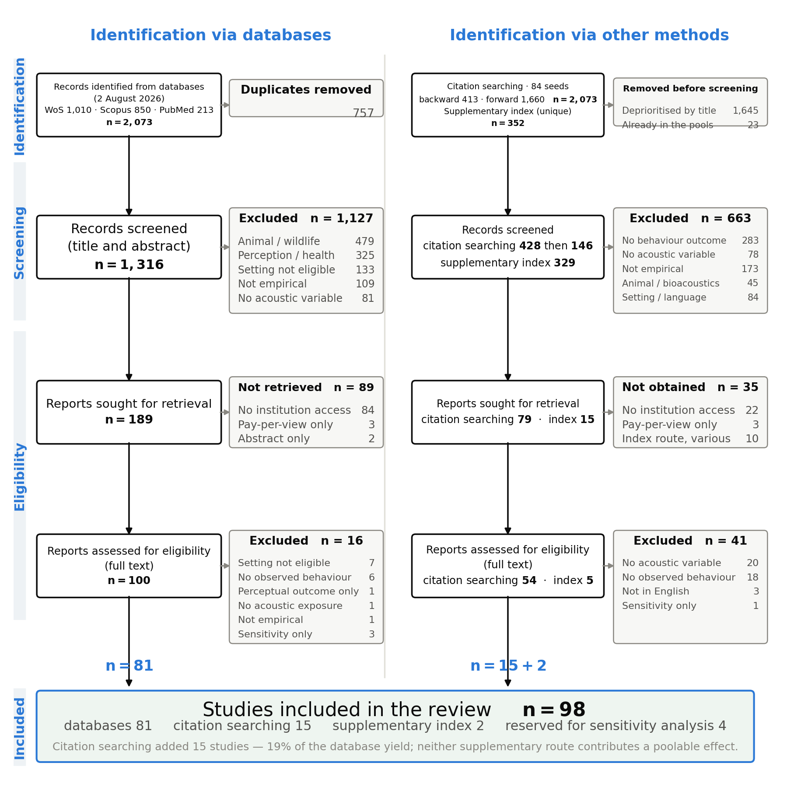
Fig. 1. PRISMA 2020 flow diagram covering all three registered identification routes: database searching, citation tracking of every included study, and a supplementary index. The dominant exclusion reason in the database branch is animal or wildlife research (479 records), reflecting the terminological overlap between soundscape ecology and human soundscape research. In the supplementary branch, 147 of 314 exclusions were non-empirical items such as book reviews and editorials, which is why absence from the three databases is weak evidence that a study was missed.
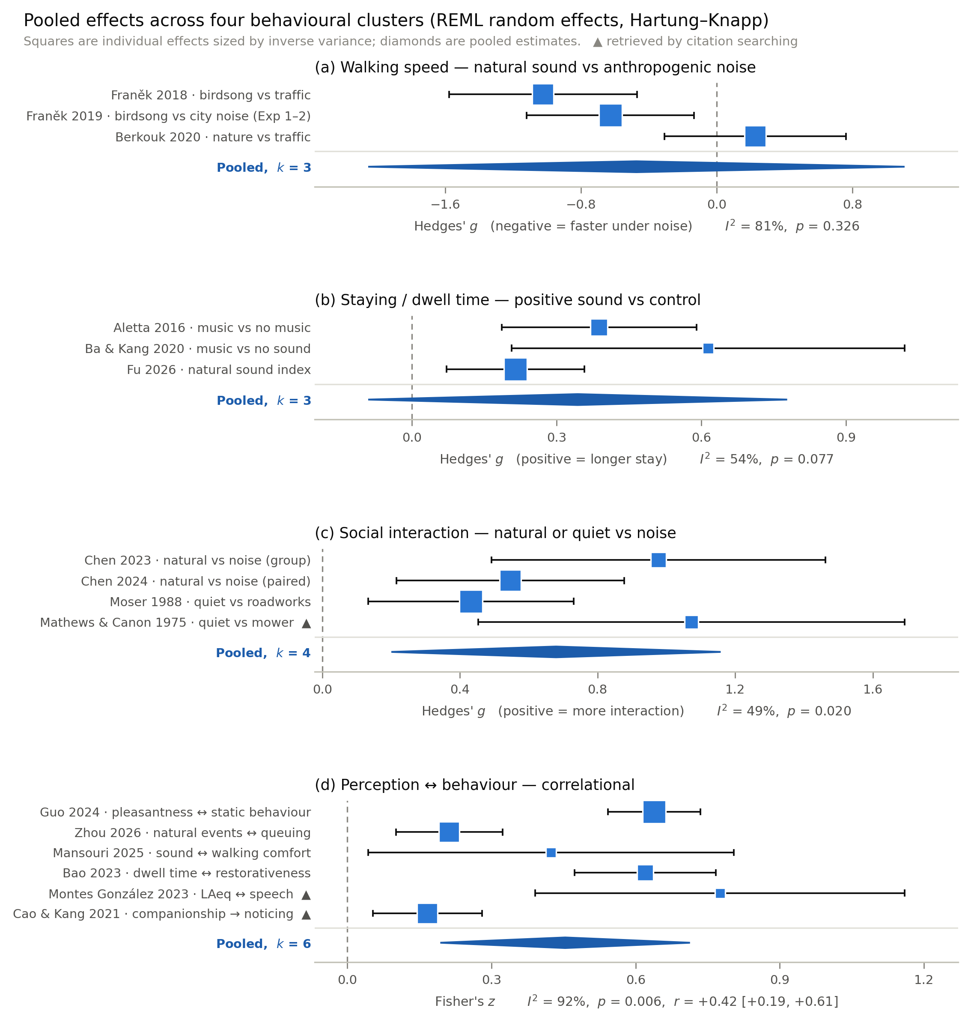
Fig. 2. Pooled estimates for four behavioural clusters, from random-effects REML with the Hartung–Knapp adjustment. Squares are individual effects, sized by inverse variance; diamonds are pooled estimates; triangles mark studies retrieved by citation searching. Only social interaction (p = 0.020) and the perception–behaviour correlation (p = 0.006) exclude zero, and both do so for the mean effect only — the 95% prediction interval includes zero in all four clusters.
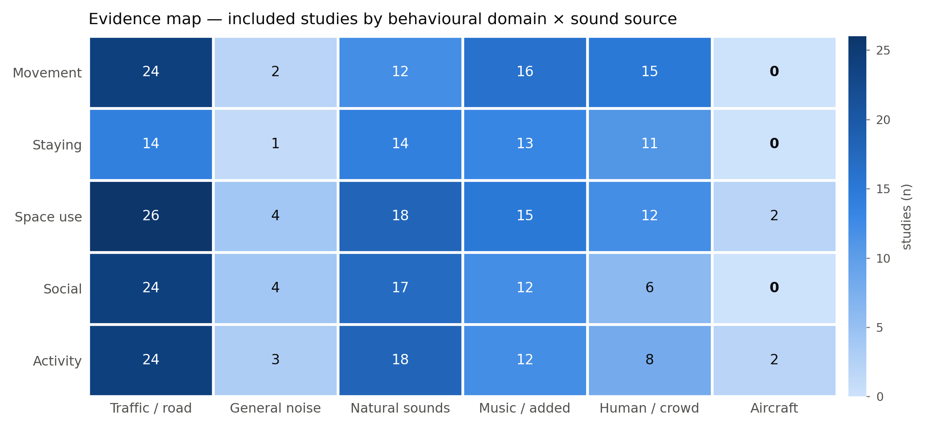
Fig. 3. Evidence map of behavioural domain by sound source. Cells count studies, and a study contributes to every cell it covers. Every combination is populated except aircraft noise, which appears in 4 domain-level records from 2 studies — the clearest gap given the size of the aircraft-noise health literature.
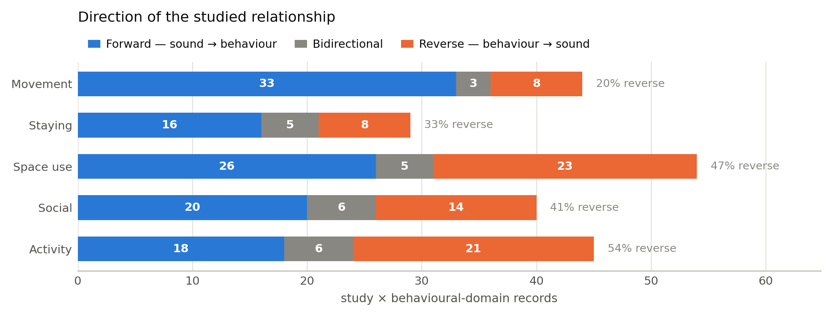
Fig. 4. Direction of the studied relationship, by behavioural domain. The unit is the study × behavioural-domain record. 74 of 187 directional records (40%) run in reverse. Movement and staying are dominated by forward designs, whereas space use, activity and social behaviour approach parity between the two directions — the empirical basis for a bidirectional framing.
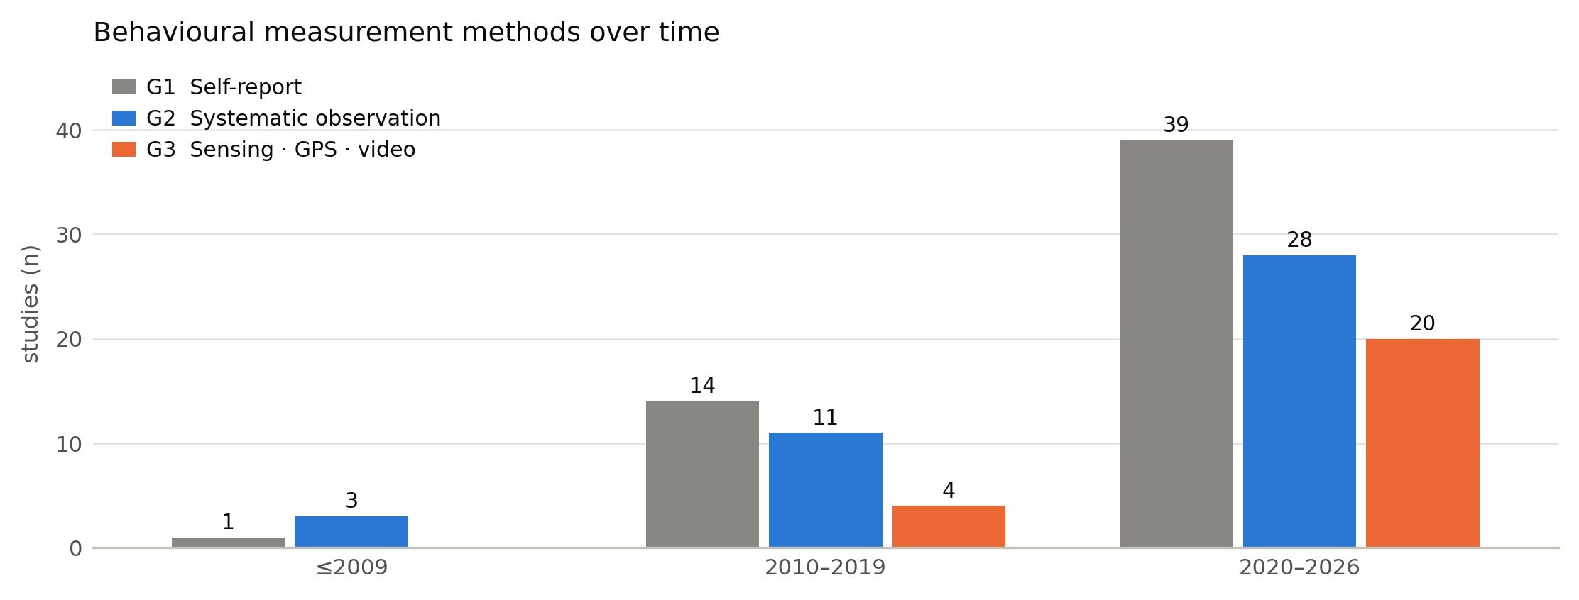
Fig. 5. Behavioural measurement methods over time. Sensing, GPS, video and big-data measurement grew from 4 studies in 2010–2019 to 20 from 2020, while self-report grew from 14 to 39 and systematic observation from 11 to 28. Generations accumulate rather than replace one another; 22 studies use two or more concurrently and therefore appear in more than one series.
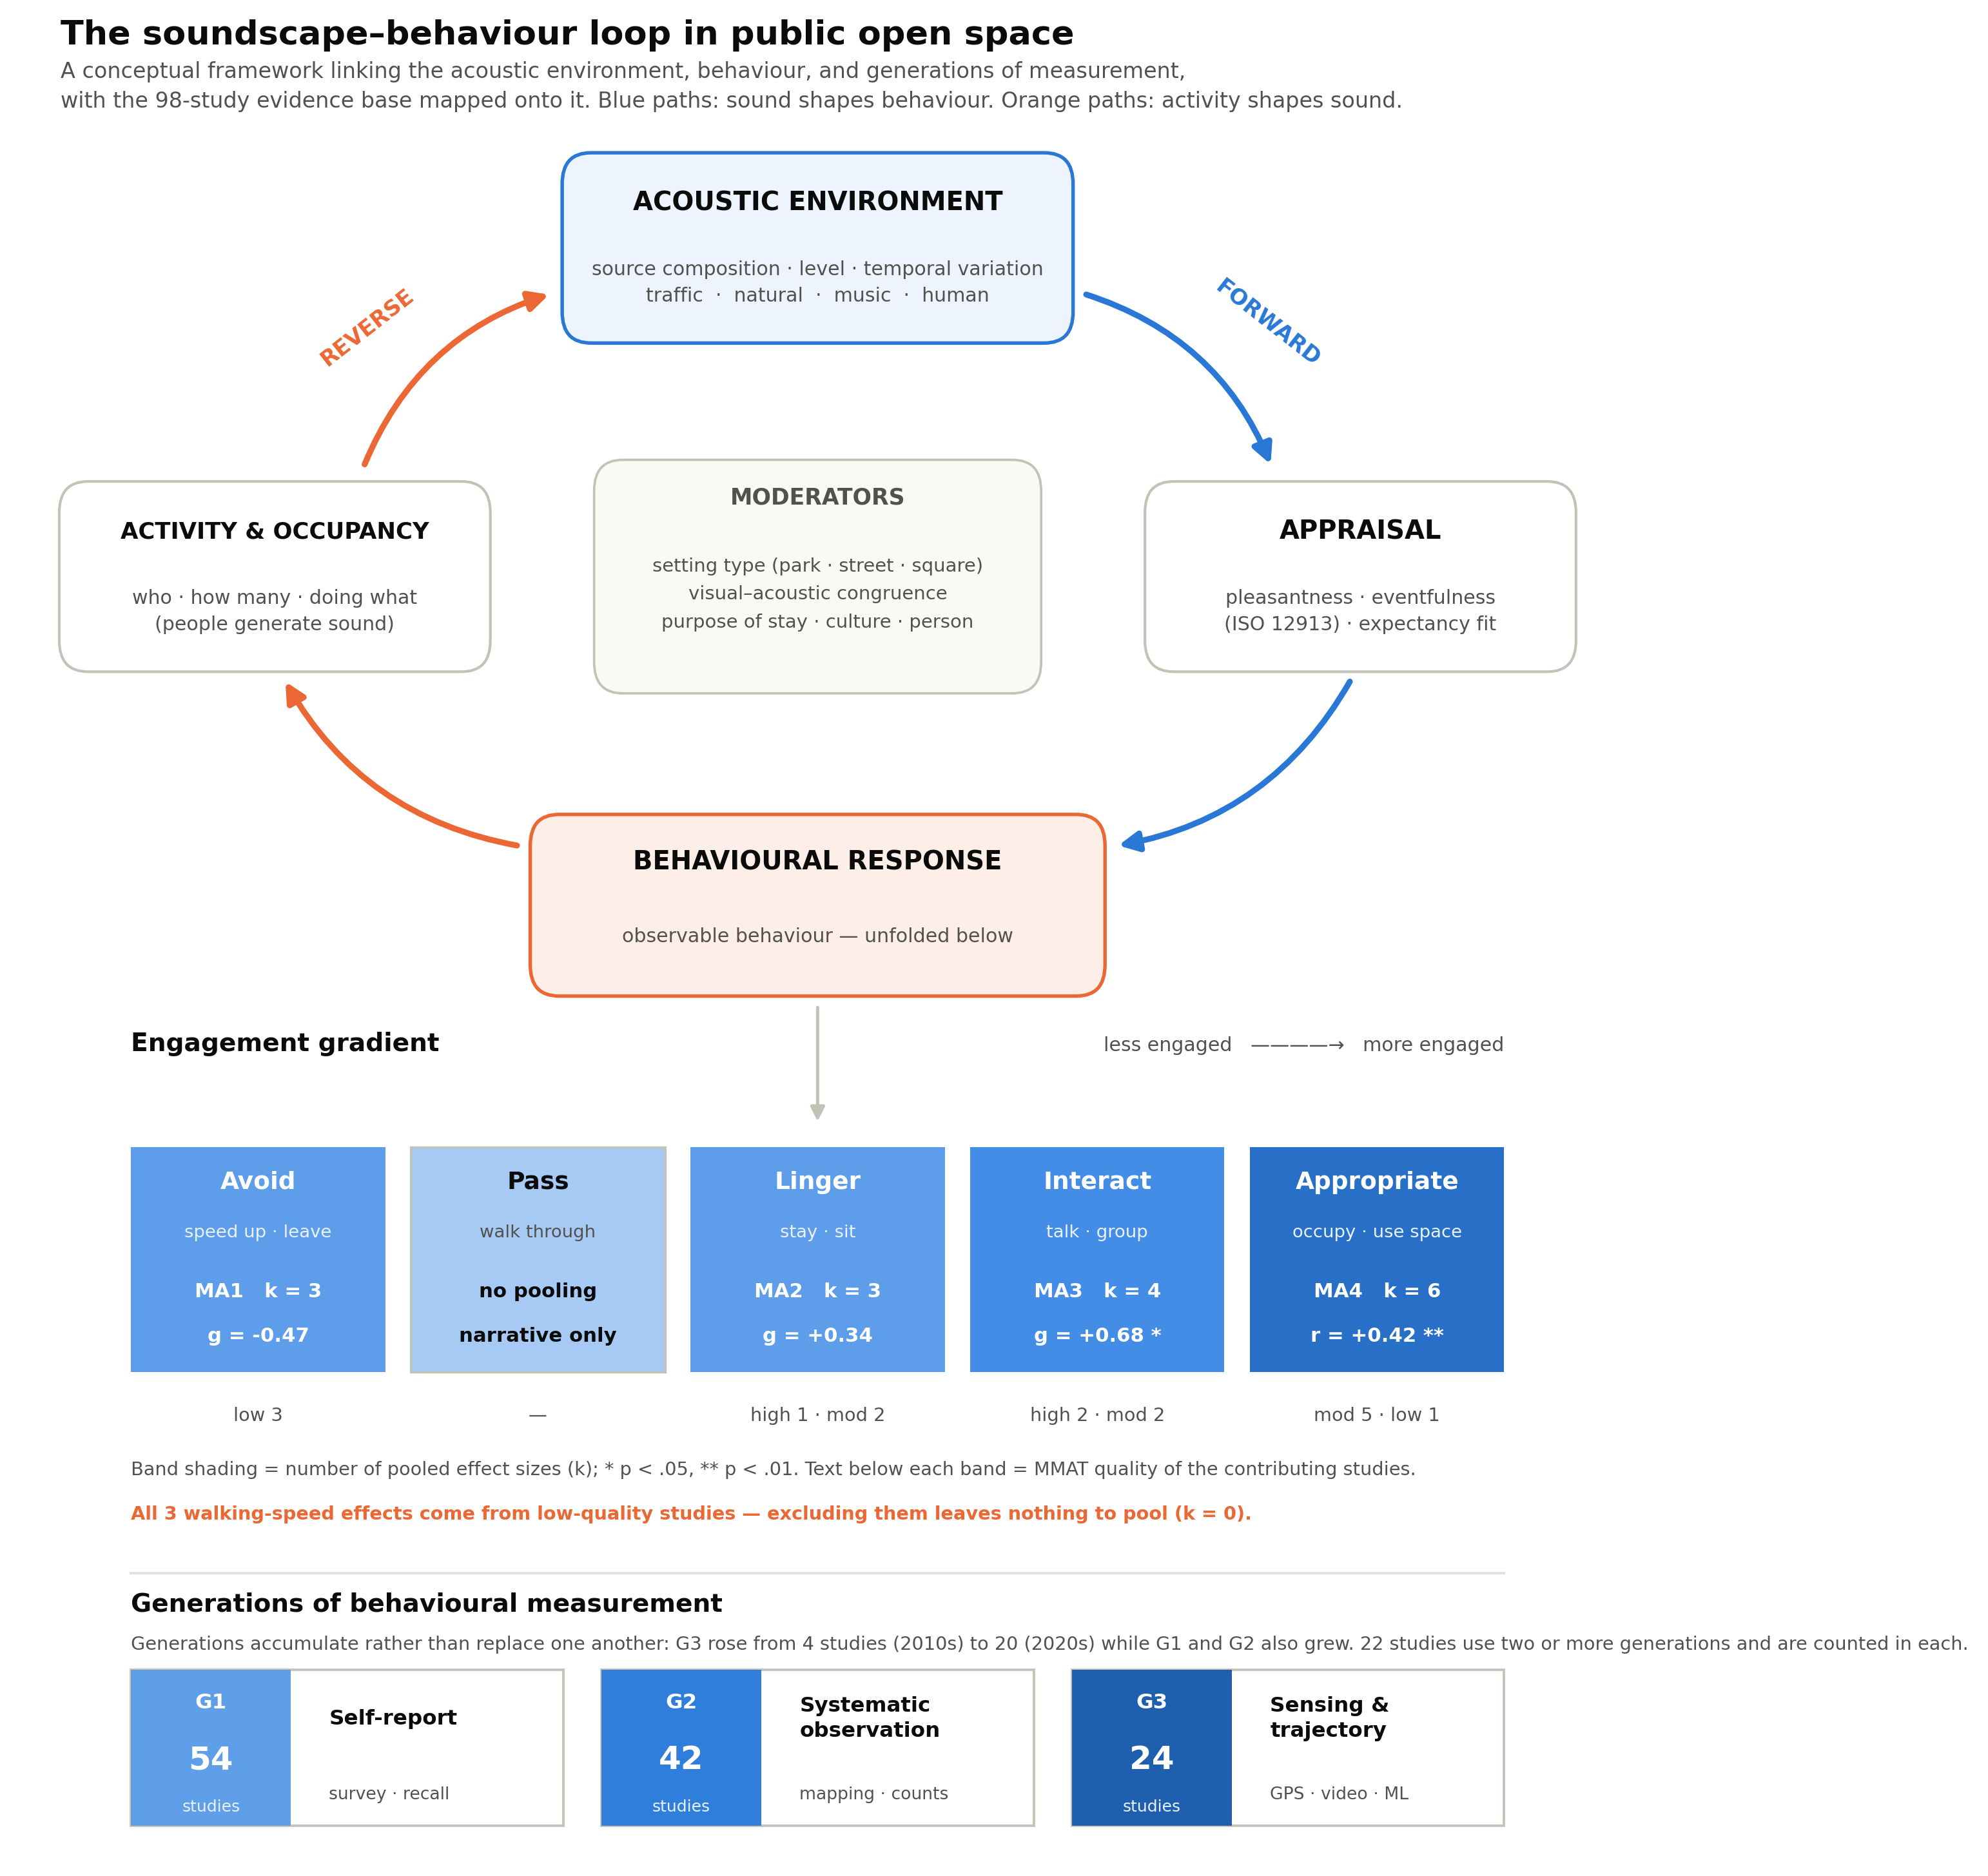
Fig. 6. Conceptual framework. The loop is bidirectional by construction: the forward path runs acoustic environment → appraisal → behaviour, the reverse path runs activity → sound production → acoustic environment. Behaviour is unfolded as an engagement gradient and each band carries the quantitative evidence attached to it. The framework's diagnostic value is visible in the leftmost band — the avoidance and walking-speed evidence, the most frequently cited claim in this literature, comes entirely from studies that MMAT rates low.
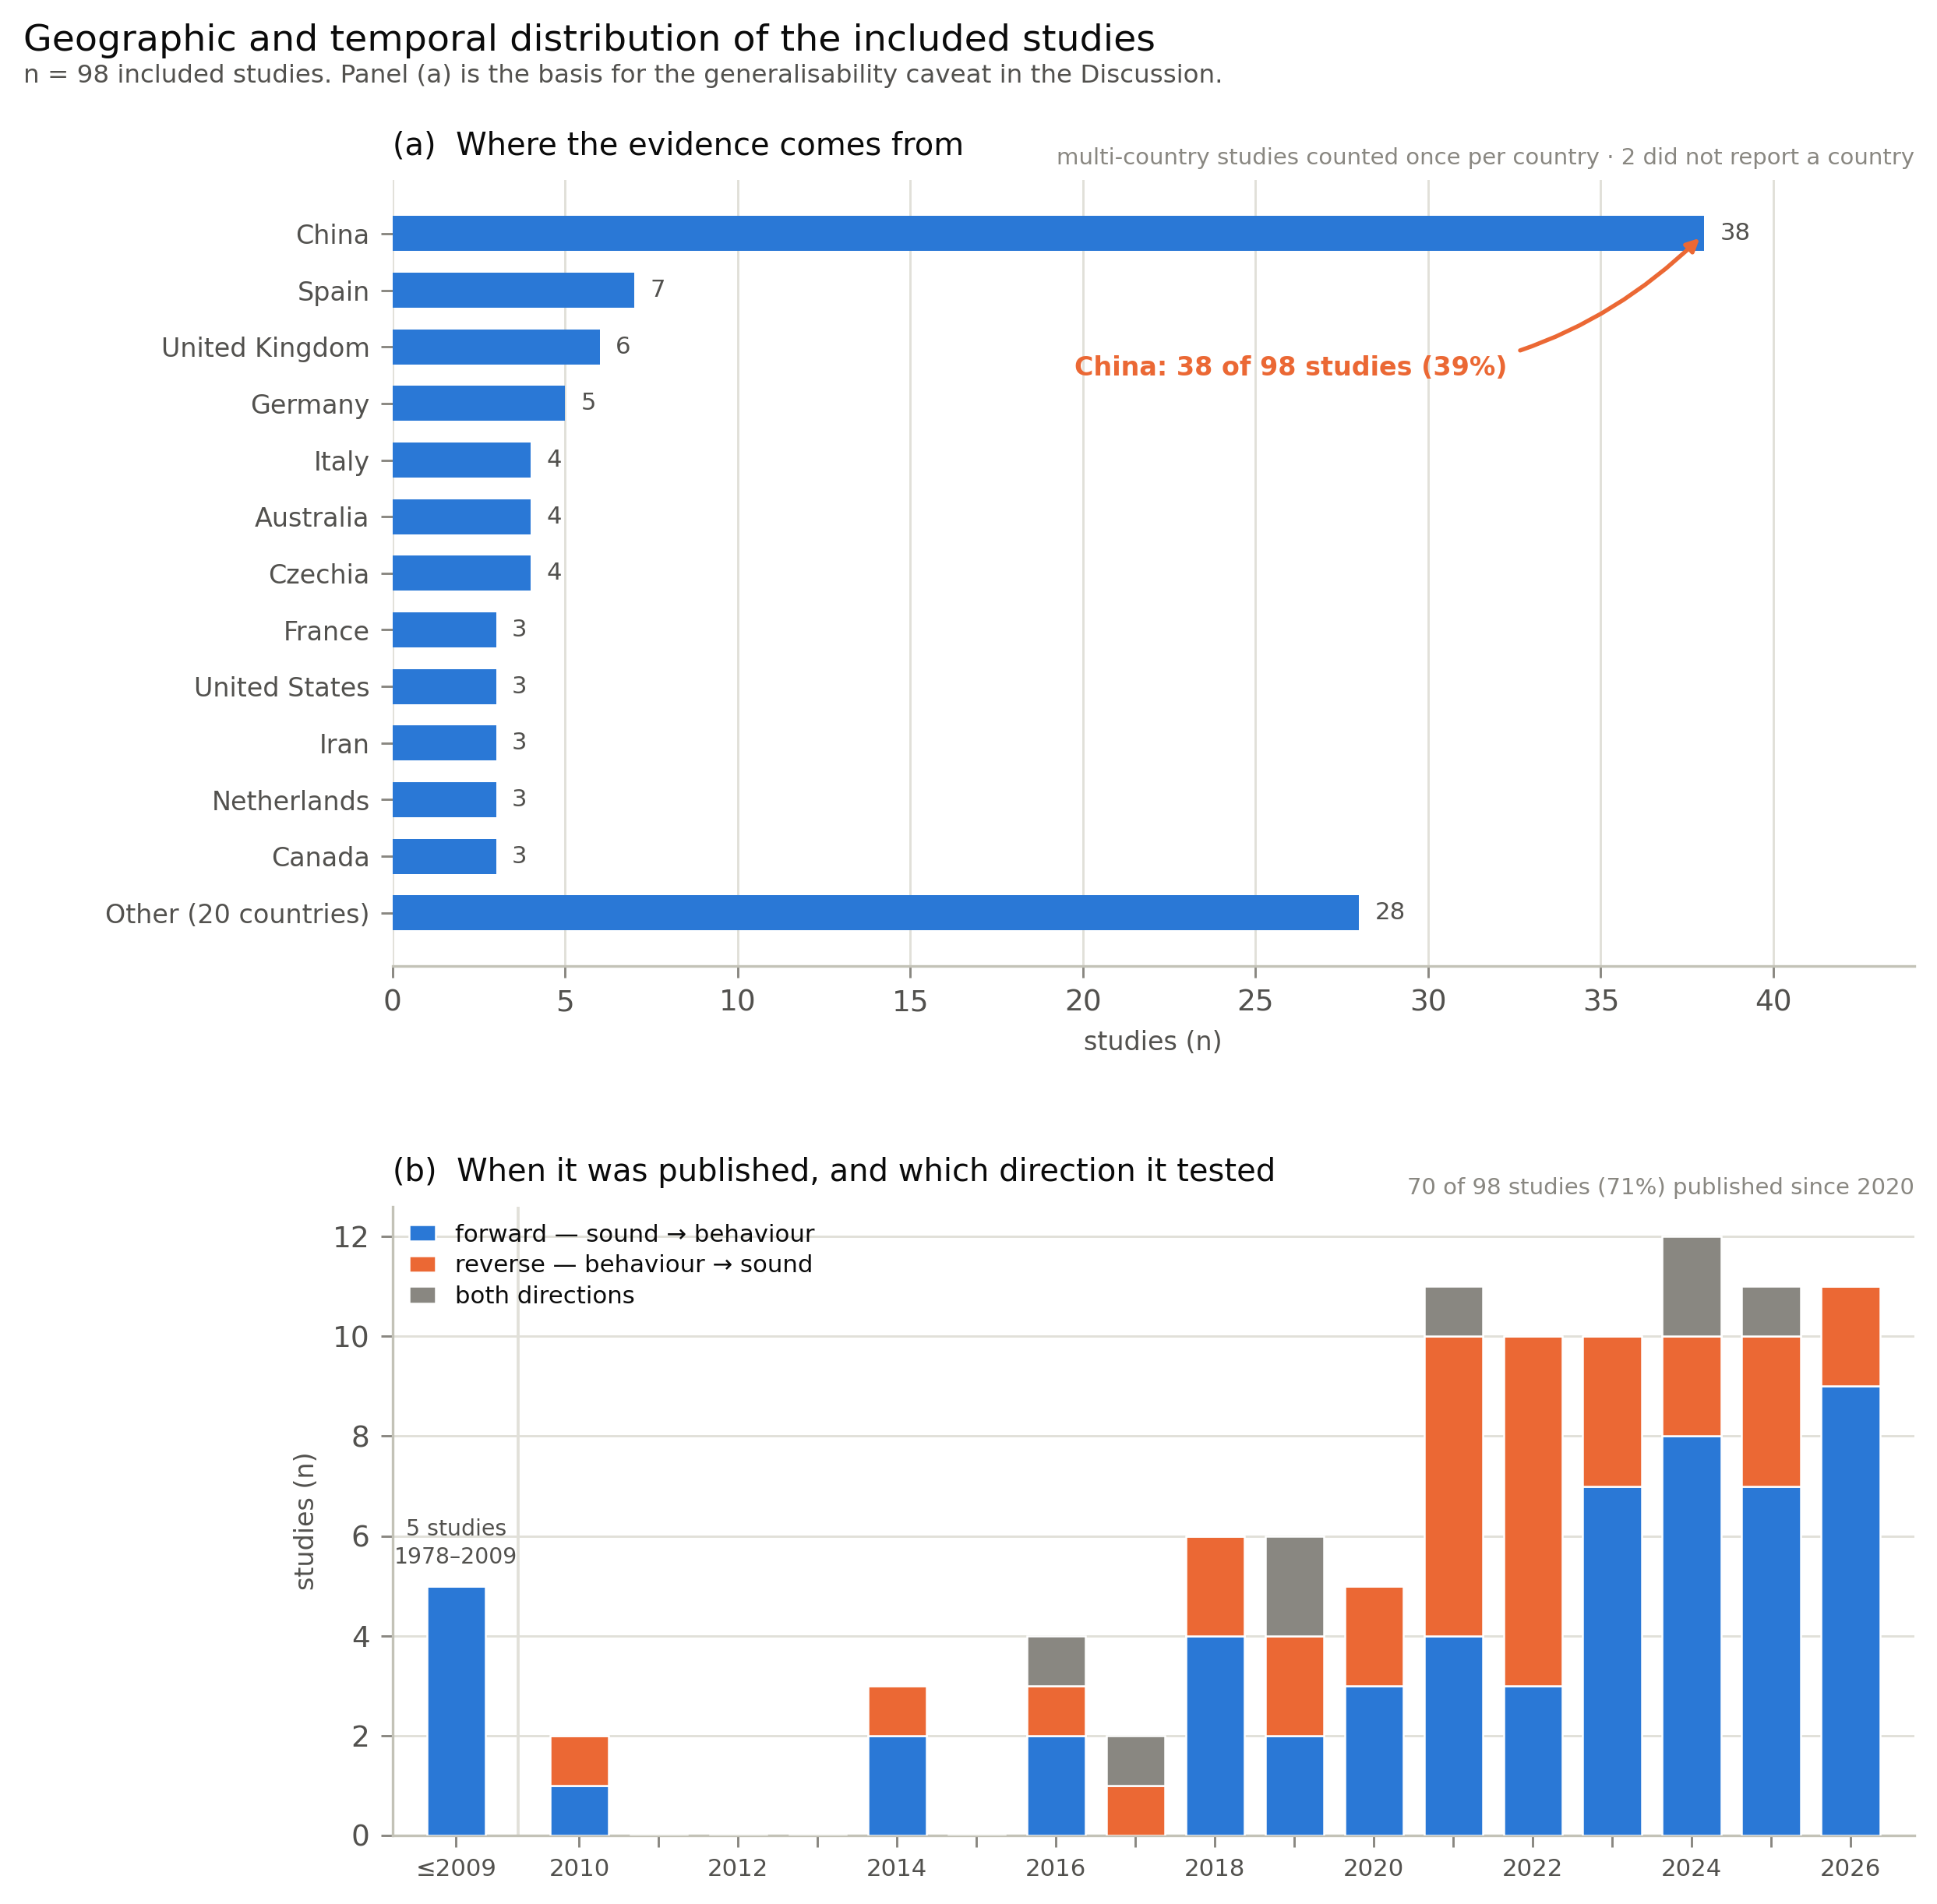
Fig. 7. Geographic and temporal distribution of the 98 included studies. (a) 38 studies (39%) were conducted in China. (b) 70 studies (71%) appeared in 2020 or later, and reverse-direction studies appear only from the mid-2010s, so the bidirectional evidence base is younger still than the corpus as a whole.
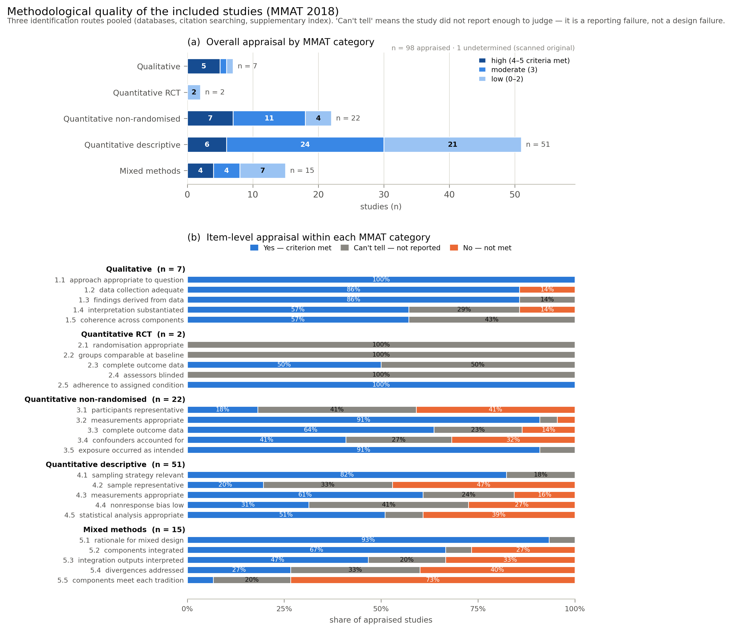
Fig. 8. MMAT 2018 appraisal. Two findings drive the Discussion. First, the two randomised studies score among the lowest rather than the highest: their reports omit the randomisation procedure, baseline comparability and blinding entirely, so the design cannot be credited. Second, the largest deficits are deficits of reporting — sample representativeness (item 4.2, clearly met in 10 of 51), low non-response bias (4.4, 16 of 51) and control of confounding (3.4, 9 of 22) fail mostly because the information is absent, not because the studies are known to be biased.

